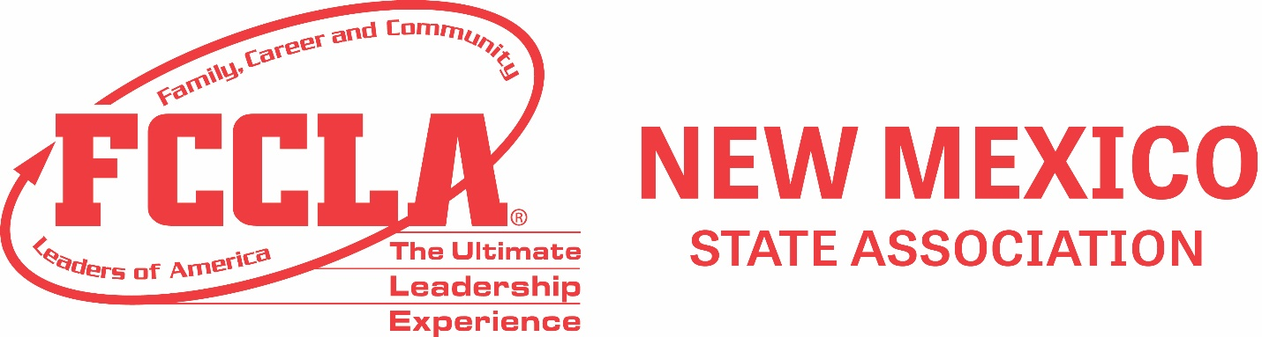

REGIONAL/STATE STAR EVENTS SCENARIOS
2024-25

Fashion Sketch –
- Prom Attire

Interior Design –
- Level 1: Teenager’s Bedroom
- Levels 2, 3 & 4: After School Youth Facility for a suburban area

Pastry Arts –
- FCCLA 80th Anniversary

