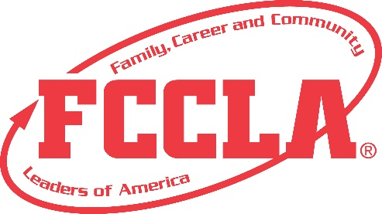
Good Stuff Scholarship
Guidelines

The Award
The Scholarship is awarded by the Family, Career, and Community Leaders of America chapters of New Mexico as a means of assisting deserving and able students who intend to major in an FCS degree program or as a CTE teacher at a state-supported institution of higher learning.

Application qualifications
- Only one scholarship application per chapter will be submitted
- Student must be a high school senior currently enrolled or previously enrolled in an FCS program
- Students must have been active and made a satisfactory contribution to Family, Career, and Community Leaders of America
- Student’s high school record should be indicated of probable success in college

Items to be submitted by the applicant
- Online application form
- ACT or SAT scores
- Official High School transcript
- 2 letters of recommendation, one from the chapter advisor and one other of your choice
Mail transcripts to: NM FCCLA, 1500 S. Ave K, ENMU-Station 61, Portales, NM 88130 ATTN: Good Stuff Scholarship

Selection Process
- A Scholarship Committee will review all materials submitted by applicants.
- The Scholarship Committee will interview and rank applications during the State Leadership Conference.
- The winner will be announced at one of the sessions at the State Leadership Conference.

Amount of Award
The amount and number of scholarships will be determined by the funds available and upon recommendation of the Scholarship Committee.

application Link and deadline
Good Stuff Application Link
The application deadline is –February 1 of the current year.

