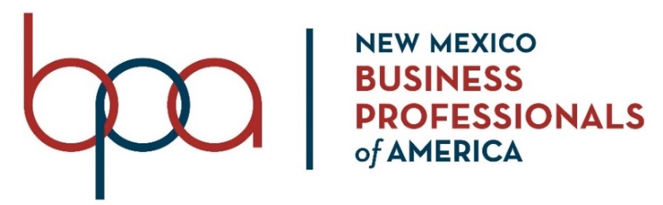
Calendar of Events
2022-2023

August
1 |  | Online Affiliation OPEN – https://www.registermychapter.com/bpamem/
1 |  | NMACTE Conference & CTSO Advisor Academy Registration – OPEN www.thinkregistration.com/ACTE/NM/
September
1 |  | Fall Leadership Conference Registration – OPEN https://www.registermychapter.com/flc/nm
14 |  | CTSO Advisor Academy
15-16 |  | NM ACTE Conference
October
1 |  | Fall Leadership Conference Registration – CLOSED
17 |  | Fall Leadership Rally – Marriott Pyramid, Albuquerque
18 |  | Fall Leadership Rally – Bulldog Training Center, Artesia
19 |  | Fall Leadership Rally – DACC-East Campus, Las Cruces
November
1 |  | Initial Membership Deadline
15 |  | Pin Design Entry - Emailed by 5 pm
30 – Dec 3 |  | ACTE Vision – 2022, Las Vegas, NV
December
1 |  | State Conference Registration – OPEN https://www.registermychapter.com/bpa/nm
TBD |  | Region 4 Conference
6 |  | Region 3 Conference – NM Highlands University, Las Vegas
7 |  | Region 1 Conference – FMS Cate Center, Farmington
7 |  | Region 2 Conference- ENMU, Portales
10 |  | Region 5 Conference – Carlsbad Early College HS, Carlsbad
10 |  | Region 6 Conference – Mountainair
January 2023
20 |  | Online State Conference Registration CLOSED (midnight)
20 |  | State Officer and National Officer Candidate Application DUE
25 |  | Hotel reservations DUE – Marriott Pyramid
30-Feb 4 |  | Online Testing Window - Objective tests and events with an objective portion.
February 2023 |  | CTE Month
1 | All pre-submitted materials DUE to the online submission website by 8:00 pm NO EXCEPTIONS  Torch Award Resume, Wanda Harriman Scholarship, NM Business Cup Application DUE
6-11 | Online Testing Window – Open Events only
20-22 | BPA State Leadership Conference, Marriott Pyramid, Albuquerque
21 | BPA Board Meeting
March 2023
30 | Payment for SLC DUE
April 2023
1 | Trading Pin Order Form DUE to State Office NO EXCEPTIONS
26-30 | BPA National Leadership Conference, Anaheim, CA
May 2023
June 2023
 | CTSO State Officer Training, Portales, NM (MANDATORY – NO EXCEPTIONS)
Updated – 8/29/22

